Curriculum Vitae
Name : | Hawra Habib Abbas Al Qambari
Nationality: | Bahraini.
Birthday: | 19/3/1992
Marital Status:  Religion:  C. P. R. | Married  Muslim  920303170
Address: | flat 22, House 336, Road 217, block 402
Phone | 33703655 _ 33167704
Email: ihawra2@gmail.com
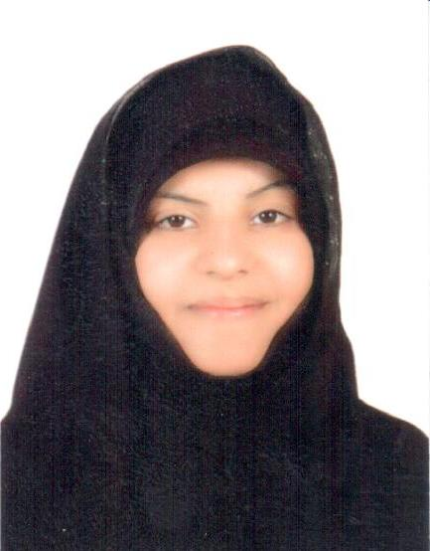
Personal Details:

Education:

- Bachelor in science from UNIVERSITY OF BAHRAIN FROM 2010 TO 2014.
- JIDHAFS SECONDRY SCHOOL FROM 2007 TO 2010.

Working experience:

I'm teaching some students in my house all subjects from 2001 to 2014.

Languages:

Arabic and English

Please feel free contacting me in the above telephone number.
Thanks…

